4 Empirical evidence

In the following chapter, the question why young adults and their parents cohabitate is addressed using empirical analysis. In doing so, the explanatory power of the revised model is evaluated and the hypotheses highlighting the added features are tested. To begin with, descriptive statistics are shown, giving a ﬁrst insight into the data. This includes general parental and ﬁlial characteristics as well as a more detailed look into the age of home-leaving using bivariate statistics. Next, inferential statistics are used to test the developed model, giving special attention to the newly added features. In total, four regression models are estimated.

4.1 Descriptive statistics

This chapter is intended to give a broad overview of the composition of the sample and the characteristics of the most important variables. It is divided into two sec- tions, starting with a short overall view of ﬁlial and parental characteristics. Next, more detailed descriptive analyses regarding the age of leaving home and intergen- erational cohabitation are presented. It should be noted that all data presented in this chapter are weighted as described previously.

In the following, the young adults’ gender, age, their educational level, occupational status, marital and parenthood status are outlined.

The data set consists of 12.509 young adults with an equal share of women and men. On average, they are 29 years old (SD: 5.48). While the ma jority (66.44%) have already started working, about one quarter (17.44%) is still in education and 8.99% are currently in search for a job. Roughly four out of ﬁve (81.38%) young adults have completed upper secondary education of which about one quarter (24.46%) has further proceeded to tertiary education. With regard to their marital status, around two thirds (64.15%) of young adults have never been wedded as opposed to approximately one third (29.02%) who are married. 68.88% have no children. As a last point, 26.79% of young adults live in the same household as their parents and another 3.95% live in the same building. The remainder of young adults live

one their own with one third (33.87%) being resident less than 5km away from the parental home and 20.90% living more than 100 kilometres away.

Before presenting some general features of the young adults’ parents, it has to be noted that due to the data structure, parents who have more than one child in the speciﬁed age range will appear repeatedly in the data set, viz. once for every young adult included. Therefore, when describing the data, I do not refer to the parents individually but indicate the share of children who has e.g. a retired mother. The features which will be outlined include the age of the young adults’ parents, the age when becoming parent the ﬁrst time, the support provided by them, their educational level, their current occupation, perceived health status, their number of children, relationship statusa as well as home ownership status.

The young adults’ mothers are on average 56.94 years old (SD=6.66) while their fathers are around 2.5 years older (59.49; SD=6.22). They were on average 26.45 years old when becoming parents for the ﬁrst time. Around 17% of the parents indicate to support their parents on a regular basis, while only approximately 9%

help out their children more or less frequently.

|  |  |  |
| --- | --- | --- |
| Members of parental household | Cohabitating young adult | Independently living young adult |
| Siblings under the age osf 20 | 18.30% | 9.0% |
| Siblings aged 20 to 39 | 55.72% | 11.36% |
| Grandparents | 2.45% | 2.75% |

Table 3: Members of the parental household diﬀerentiated by recidency status of young adult; source: own calculations

Of the fathers, about one third (31.04%) is retired whereas only 16.16% of the moth- ers have entered retirement. As could be expected, the share of homemakers is much higher for women (19.46 %) than for men (0.33%). Over 50% of women (53.17%) as well as men (57.54%) are employed in contrast to 5% unemployed persons and

4% who are sick or disabled. The median annual income of the fathers amounts to about 25.377e; the mothers’ income is with approximately 16.500econsiderably lower. The percentage they will receive in retirement corresponds on average to

50.56% of their current earnings.

Regarding the educational level, the picture seems quite homogenous, with 72.61% of fathers and 68.29% of mothers having at least completed upper secondary edu- cation. The ma jority of the young adults’ parents perceive their health as being at least “good” (65.55%).

On average, the young adults’ parental households have 2.56 children. 11% of young adults are single children and 15.6% come from families with four and more children. Looking at their parents’ household composition, see table 3 on page 44, it is ﬁrstly evident that only a very small share of parents lives with grandparents. Next, presumably due to the age diﬀerence between co-residing and independently liv- ing young adults, those who co-reside with their parents are more likely to have a younger sibling or sibling of similar age in the parental household than young adults who no longer live with their parents.

About one quarter of the young adults’ parents is living without the other parent, e.g. because they are widowed or their partner is currently institutionalized. Finally,

73.13% of young adults have parents who own their current home. Its median value amounts to approximately 200.000e.

At the national level, three indicators were added to the data set: unemployment rate, family expenditure and expenditure for old age security. As for the former, less than 5% of the active population are unemployed in Austria, Switzerland and the Netherlands. The ma jority of countries instead have unemployment rates of around

8%, with only Estonia (16.7%) and Spain (19.9%) over the 10% limit. With regard to the countries family expenditure, Scandinavian countries invest the highest share of their GDP (around 4.0%). Most other countries have slightly smaller values (around

3%), with only Southern European countries funding family support with less than

2% of their GDP. Surprisingly, Italy, as well as France and Austria, promote old age security with values corresponding to over 10% of their GDP. Contrarily, Luxem- bourg, Switzerland and the Netherlands invest only around 5% in this sector.

|  |  |  |
| --- | --- | --- |
| Contact frequency | Same household | Same building |
| Daily | 90.27% | 87.18% |
| Several times a week | 5.76% | 10.41% |
| Once a week or less | 3.97% | 2.42% |

Table 4: Contact frequency of young adults living in the same household, resp. same building as their parents

Based on the empirical analyses of Szydlik and Isengard (Isengard and Szydlik, 2012) as well as Choi (Choi, 2003), in this paper, near coresidence and coresidence are not distinguished. However, substantial diﬀerences in day-to-day life might exist. The families’ contact frequencies are quite revealing in this regard. Table 4 on page 46 compares young adults and their parents who either live in the same household or same building. As can be seen, the contact frequencies of the two groups do not diﬀer signiﬁcantly. Taking also into account the empirical results just referred to, it can be safely assumed that the informative value is not biaes by not diﬀerentiating between both forms of intergenerational cohabitation.

In the following section, young adults who currently live at home and those who have already moved out will be compared.

As might be expected, those young adults who live with their parents are on av- erage younger (26.19) than those who have moved out (30.89). Figure 1 on page

47 shows the distribution of young adults across diﬀerent occupational statuses in relation to their place of residence. As those young adults who still live at home are on average roughly 4.5 years younger than their independently living peers, it is not surprising that a high share of them is still in education. To be speciﬁc, 29.85% of young adults who cohabitate with their parents are in education as opposed to

11.10% of residentially independent young adults. In turn, a much higher share of young adults who have moved out (60.98%) is full-time employed compared to those co-residing with their parents (37.19%). Moreover, unemployment is more common among young adults in cross-generational living (16.12%) than among those who left the parental home (6.03%).

As anticipated, the vast ma jority of young adults living with their parents are neither

married (89.44%), nor has children (11.12%), whereas half (49.89%) of their peers

who live independently have (been) married and 42.46% are parents.

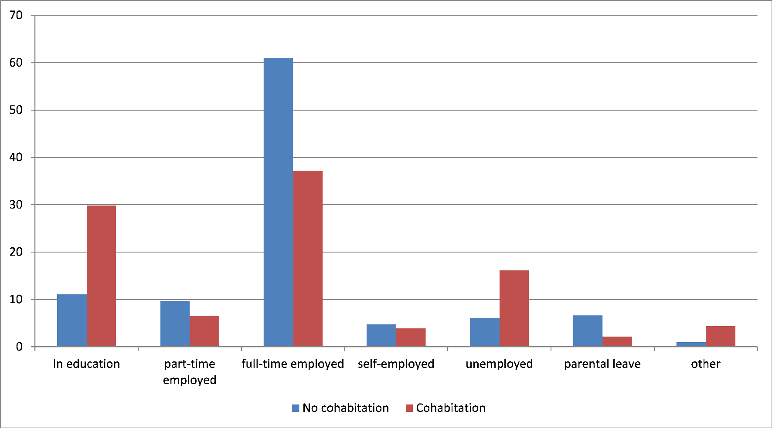

Figure 1: Bar graph regarding the distribution of young adults across diﬀerent occupational statuses grouped by their place of residence; source: own calculations

Next, looking exclusively at those young adults who live independently, the age of leaving home will be examined further. As elaborated in the paper’s theory section, a higher educational level is thought to be linked to delayed residential independence. Graph 2 on page 48 displays the age of moving out separated by the young adults’ educational level. The sum of the area under each graph corresponds to one.

Since only the educational level at the time of interview is known, no when mov- ing out, only those individuals who left the parental home in the last ﬁve years are included in the subsample (n=2.745). This way, the information is tempor- ally no too heterogeneous. Due to small numbers of cases, young adults who only completed primary education as well as those with post-secondary non-tertiary edu- cation could not be included. Taking a look at the graph, it becomes obvious that moving out peaks for young adults who completed upper secondary education at around age 20 (mean: 23.88 years). In contrast, those who only completed lower secondary education leave the parental home somewhat later (mean: 24.60). Those

Figure 2: Distribution plot regarding the age of home-leaving grouped by education level; source: own calculations

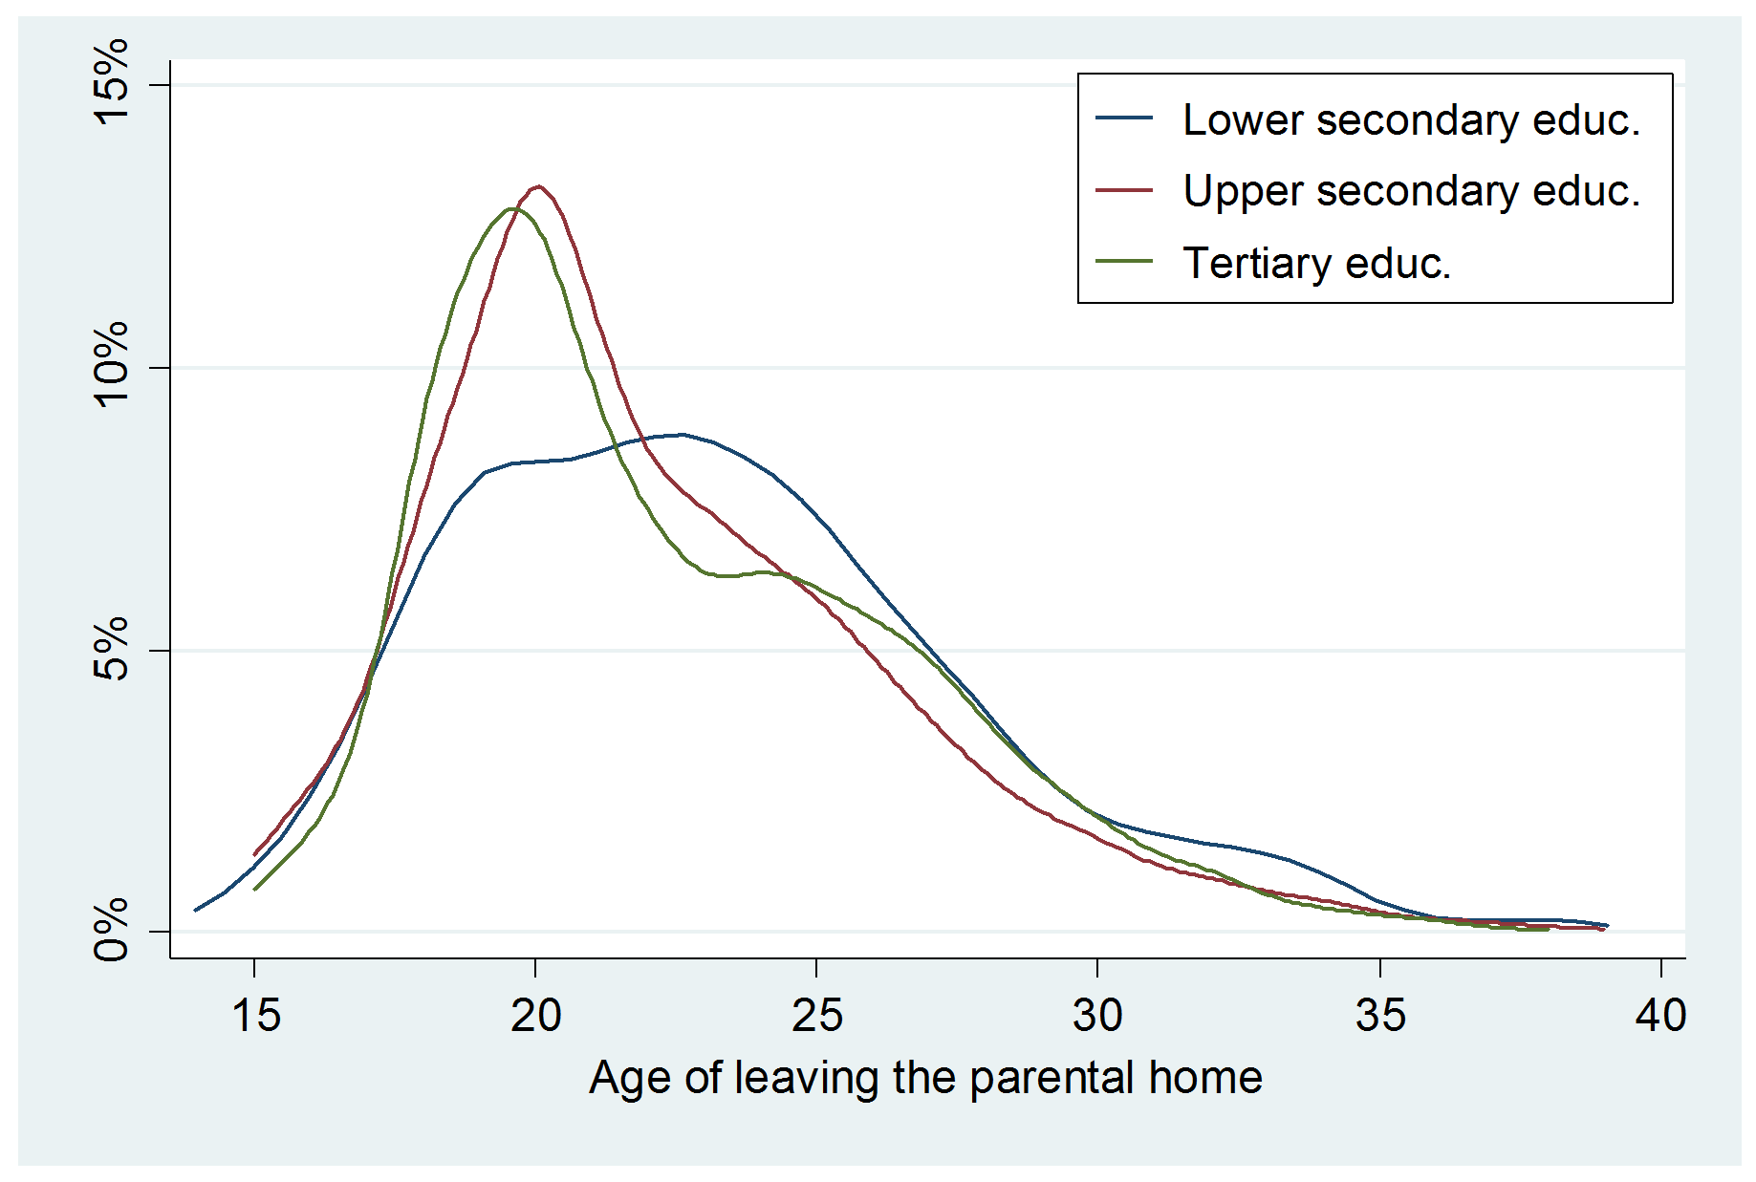

young adults who continued to tertiary education stay with their parents the longest (mean: 25.64) with only 10% gaining residential independence under the age of 21. However, between age 23 to 26 home–leaving speeds up signiﬁcantly, presumably with graduation and transitioning to employment.

Now, cross-national diﬀerences will be analysed, starting with the age of home- leaving, followed by the prevalence of cross-generational living.

Comparing the mean age of getting residentially independent, a large diversity can be uncovered. Young adults in Sweden and Denmark leave the parental dwelling earliest, around the age of 19.5. Contrastingly, Spanish young adults stay on average

26 years with their parents. All other countries fall within this age spectrum. In Germany, young adults are on average 21 years old when moving out. Young adults in the Czech Republic stay a little longer, viz. averagely 23 years. Figure 3 on page 49 provides a graphical representation of the age of leaving the parental home

Figure 3: Distribution plot regarding the age of home-leaving for the countries

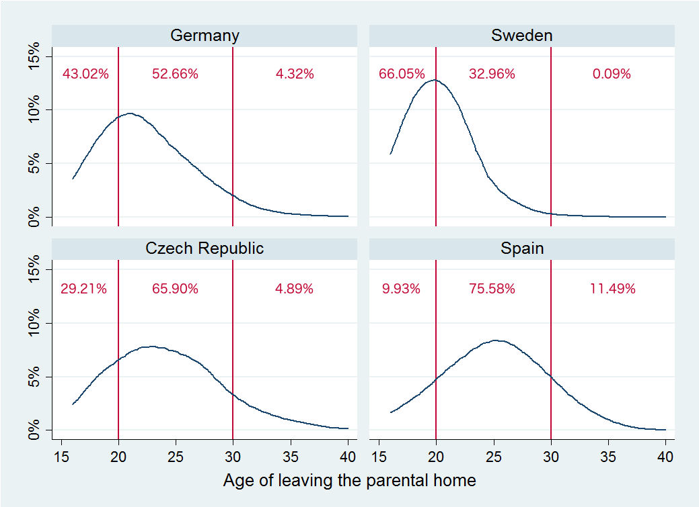

Germany, Sweden, the Czech Republic and Spain; source: own calculations

for young adults from Germany, Sweden, the Czech Republic and Spain (n=6.123). While almost half of the young adults in Germany have left home by the age of 20, two thirds of Czech young adults still live with their parents and move out mostly in their twenties. In both countries, around 4% leave the parental home in their third decade of life. As mentioned earlier, Swedish young adults seek residential independence very early. The ma jority leaves their parents’ home before turning

21 and almost nobody lives with their parents longer than 30 years. In Spain, the picture is quite diﬀerent: only one out of 10 young adults leaves their childhood home in the ﬁrst two decades of life. Instead, the ma jority of Spanish young adults set up their own household in their twenties and one tenth leaves after their 30th birthday.

Figure 4 on page 50 illustrates the current residency status of young adults. As already mentioned above, Scandinavian young adults are the least likely to stay with their parents, while young adults in Southern Europe cohabitate more fre- quently. Young adults from Western and Eastern European countries lie between

those two extremes.

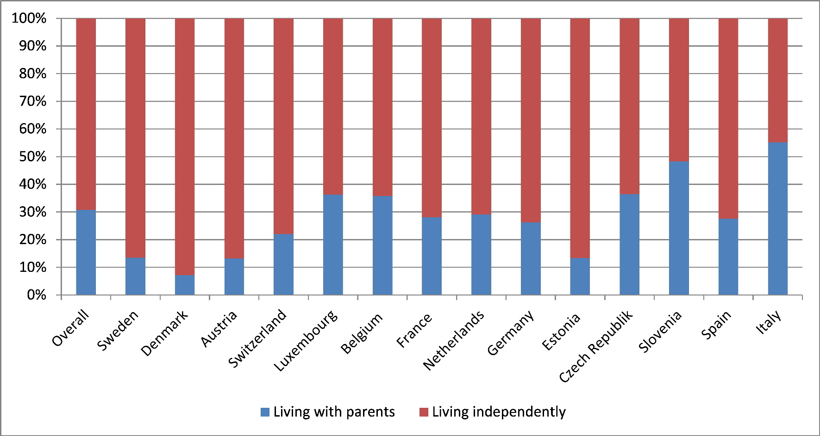

Figure 4: Bar graph regarding the prevalence of intergenerational cohabitation grouped by countries; source: own calculations

4.2 Inferential statistics

In the following subchapter, the results of multivariate analyses will be presented. As mentioned in the section on methodology, additional variables are included step- by-step. The ﬁrst regression model explores causal relations at the individual level. Next, two models add indicators at the household level: one relates to the ﬁrst hy- pothesis (H1a –1c), while the other refers to the second (H2) and third hypotheses (H3a–3b). In a last step, as formulated in the fourth and ﬁfth hypotheses, the im- pact of macro–level determinants is examined. Tables 5 to 9 demonstrate the results of the corresponding logistic regressions. Control variables are considered as well, but are not presented.

(a) Individual level

The ﬁrst model includes characteristics of the young adults, i.e. their gender, age, educational level, stage of family formation and occupational status. A chi-squared goodness of ﬁt test comparing the ﬁrst model against a constant only model was statistically signiﬁcant (Wald χ2 (17) = 1821.04, p < .001), indicating that the predictors distinguished between young adults who live independently and those who cohabitate with their parents. In order to as- sess model ﬁt, McFadden’s adjusted R2 is used. According to him “values of

0.2 to 0.4 for rho-squared represent excellent fit” (McFadden, 1979, p.306). Consequently, with a pseudo R2 of 0.234 the present model ﬁts the data ad- equately. The results of the logistic regression can be found in table 5 on page

52.

|  |  |
| --- | --- |
| Indicators relating to young adults | Model 1 Model 2 Model 3 |
| Occupational status  Reference: Full-time employment  Part-time employment Self-employment Unemployment Vocational training  Parental leave/homemaker  Level of education  Reference: Pre-primary & primary education  Lower secondary education  Upper secondary education  Post-secondary non-tertiary education  Tertiary education  Stage of family formation  Reference: Unmarried, no children  Unmarried, children Married, no children Married, children  Age  Gender: female  Control variables  Features of parental household  Individual parental characteristics | 1.60** 1.86*** 1.82*** (0.24) (0.24) (0.25)  2.03*** 1.14* 1.36+  (0.37) (0.22) (0.22)  3.64*** 2.90*** 2.73***  (0.48) (0.33) (0.32)  1.80*** 1.43*** 1.41***  (0.20) (0.13) (0.14)  1.48+ 1.13 1.11  (0.34) (0.25) (0.24)  1.05 0.69 0.87 (0.39) (0.22) (0.29)  0.92 0.61 0.81 (0.33) (0.19) (0.26)  0.90 0.54 0.77 (0.36) (0.18) (0.27)  0.60 0.04* 0.55+  (0.21) (0.13) (0.18)  0.24*** 0.39*** 0.43*** (0.03) (0.05) (0.06)  0.05*** 0.13*** 0.13*** (0.01) (0.02) (0.02)  0.09*** 0.20*** 0.20*** (0.01) (0.02) (0.02)  0.85*** 0.92*** 0.86*** (0.01) (0.01) (0.01)  0.62*** 0.66*** 0.65*** (0.05) (0.04) (0.04) No Yes Yes  No Yes Yes  No No Yes |

Table 5: Regression results concerning the young adults’ characteristics, Models 1 to 3; eﬀect sizes as odds ratios; source: own calculations.+ p < 0.1, * p < 0.05, ** p

< 0.01, *** p < 0.001

Interestingly, the young adults’ educational level exerts no signiﬁcant eﬀect on the probability of intergenerational cohabitation. This ﬁnding is contrary to the results of most other studies, (see e.g. South and Lei, 2015; Sandberg- Thoma et al., 2015). However, it is for the most part explained as an indir- ect eﬀect due to diﬀerences in occupational statuses depending on a person’s educational level, e.g. a low educated individual being more likely to be un- employed or holding a precarious job. Therefore, it could be assumed that by integrating a rather diﬀerentiated measure of the young adults’ occupational status, no direct eﬀect attributed to the educational level remains.

The results relating to a young adult’s occupational status reﬂect what the ma jority of other studies discovered as well: young adults in part–time em- ployment are on average about 27% more likely to live with their parents than their peers working full–time (p<0.001). Similarly, the probability of unem- ployed young adults to cohabitate is averagely 2.6 times higher (p<0.001). As expected, young adults in education are on average 44% more likely to be part of a multigenerational household which includes their parents (p<0.001) than the reference group. Equivalently, young adults who are on parental leave or homemakers also have a 45% higher chance of living with their par- ents than young adults in full–time employment. It will be very interesting to see whether these strong eﬀects persist when more variables are added to the model.

The life cycle approach predicts that adult children who are married have and increased need for residential independence and are thus expected to only rarely live with their parents. Similarly, having children is assumed to increase one’s need for privacy. These assumptions hold true: unmarried young adults with children are averagely more than twice (2.86 times to be exact) as likely to live independently compared to their childless peers (p<0.001). Married young adults seem to value their residential independence even more: Those with children are on average approximately ﬁve times less likely to live with their parents, the childless even seven times less likely (p<0.001). These res- ults raise the question why being married has a much stronger impact on the

probability of intergenerational cohabitation than being a parent. Presumably, this outcome is due to the fact that unmarried young adults with children in- clude both singles raising a child on their own as well as unmarried parents in a relationship. Thus, this group might include young adults who in fact rely on parental support. By contrast, married young adults can be assumed to need less assistance. Unfortunately, there is no information in the data set on the relationship status of unmarried young adults.

Naturally, with increasing age young adults are less likely to live with their parents. With every year, intergenerational cohabitation becomes on average approximately 11% less likely (p<0.001). Concluding with the young adults’ gender, compared to men women have on average only a 1/0.72 chance of co- habitation. That is, they are about 39% less likely to live with their parents than men (p<0.001). This ﬁnding is in line with the assumption of Schmert- mann and colleagues, who hypothesise that co-residence of sons is most likely when parents are relatively young and do not need assistance, whereas daugh- ters cohabitate predominantly with their frail parents whom they support and provide care for (Schmertmann et al., 2000).

(a) Household level

In a second model, characteristics of the parental household, viz. other res- idents and features of the accommodation, are added into the regression (see table 6 on page 55). A likelihood-ratio test, which compared the ﬁtted mixed model to standard regression with no household-level random eﬀect, revealed that the former ﬁts the data signiﬁcantly better (p<0.001). Both the result from a likelihood-test as well as Akaike’s Information Criterion, which equals a diﬀerence of 1,500, provide very strong support for the current model in comparison to the former.

|  |  |
| --- | --- |
| Indicators of the parental household | Model 2 Model 3 |
| Household composition  Partner  Under-age children  1 child  2 and more children  Young adults  1 young adults  2 and more young adults  Grandparents  Home ownership & value of parental home  Reference: Tenants  Proprietary: 1st quartile Proprietary: 2nd quartile Proprietary: 3rd quartile  Proprietary: 4th quartile  Control variables  Individual characteristics of young adult  Individual parental characteristics | 1.34** 1.35** (0.13) (0.13)  0.18*** 0.23*** (0.26) (0.03)  0.01*** 0.01*** (0.01) (0.01)  3.65*** 3.64*** (0.34) (0.34)  4.39*** 5.51*** (0.73) (0.76)  1.15 1.25 (0.25) (0.29)  1.09 1.14 (0.13) (0.14)  0.91 1.00 (0.10) (0.11)  0.86 0.89 (0.10) (0.10)  0.99 0.98 (0.11) (0.11) Yes Yes Yes Yes  No Yes |

Table 6: Regression results concerning characteristics of the parental household, Models 2 to 3; eﬀect sizes as odds ratios; source: own calculations.+ p < 0.1, * p < 0.05, ** p < 0.01, *** p < 0.001

Starting with the parental partnership status, those young adults, whose par- ents share a home, have a 15% higher chance of intergenerational cohabitation than their peers with single parents. This ﬁnding contrasts the eﬀect other studies have found, see (see e.g. Mitchell et al., 2000; Isengard and Szydlik,

2012). At ﬁrst, this causal relation may seem quite counterintuitive. Though, young adults’ needs are assumed to be by far more decisive with regard to their residency situation than their parents’ needs. Parental couples may be a more attractive “home base” for young adults as they probably have more

living space available. However, the eﬀect is only signiﬁcant at the 10%-Level and should not be overinterpreted.

The ﬁrst set of hypotheses (H1a–1c) deals with the eﬀect of other co–residing family members on the likelihood of intergenerational cohabitation. Hypo- thesis 1a states that adult children of parents who accommodate younger sib- lings are less likely to live with their parents than young adults whose parents do not share their home with underaged children. Taking another look at the table, the odds ratios of having underaged children in the parental household are smaller than 1 (p<0.001). This translates indeed to a lower probability of cross–generational living. To be precise, having one young sibling co–residing with the parents reduces the chance of cohabitation by 1/0.16, that is approx- imately 6.25 times or 525%. Young adults whose parents live with two or more underaged children have an even lower probability of living with their parents. In this very restricted model it appears as though Hypothesis 1a could be temporarily supported. At this point, it has to be taken into account that this model does not control for the age of the young adults’ parents. Con- sequently, the eﬀect is probably a combination of the parents’ age eﬀect and the true eﬀect of young siblings in the parental household. The full picture will get clearer once the characteristics of the young adult’ parents are added with the next model.

Opposite to this ﬁrst hypothesis, the next assumes a neutral or positive causal relationship between parents’ coresidence with grandparents and cross– gen- erational living with young adults (H1b). At this point, it seems as there is no signiﬁcant causal relation between the presence of grandparents in the parental household and the likelihood of intergenerational cohabitation of young adults and their parents. In contrast to younger siblings in the parental household, the presence of grandparents does not seem to be linked to a higher probability for the young adult to live there. It is also conceivable that the living situation is not as hypothesised an indication of the parents’ familialistic values but in- stead resulted from the grandparents’ need for care which can be provided by

the young adult. At this opint, it is important to note that it cannot be con- cluded from the data set which family member moved in last, young adult or grandparent, since no information on the duration of cohabitation is provided for either. Thus, it is for example possible that the adult child never moved out of the parental home and the grandparent joined the household at one point, or that the young adult returned after a period of independent living and the grandparent moved in eventually.

In light of these considerations, ﬁrst results of the third hypothesis (H1c) deal- ing with the eﬀect of young adult siblings in the parental household become even more interesting, as this group of residents is most likely not in need of support. Turning to this hypothesis, at ﬁrst sight, it is evident that the odds ratios are positive, very large in eﬀect size and highly signiﬁcant (p<0.001). If one sibling of similar age (20–39) lives with the parents, a young adult’s chance of cohabitating increases almost 4–fold. If more siblings cohabitate, this probability becomes even higher. However, one should again bear in mind that this ﬁrst model only includes household characteristics and does not con- trol for individual features of the parents. Yet, their migrational status, for example, is often found to be closely linked to the likelihood of adult children staying with their parents, (see e.g. Billari and de Valk, 2007). Hence, it can be assumed that the eﬀect size decreases considerably once more indicators are included into the model.

The last indicator considered in this model is the ownership status of the par- ental residence and its value. The latter is thought to be indicative of the attractiveness for a young adult to live there. The determinant is included as a categorical variable with the reference group being tenants. Starting with young adults, whose parents own their accommodation with the value being in the lowest quartile of the distribution, in accordance with theoretical assumptions, the probability of intergenerational cohabitation is 22% higher than for adult children whose parents are tenants. Yet, there are no signiﬁc- ant diﬀerences between children of parents who own property in the second

and third quartiles regarding the likelihood of intergenerational cohabitation and those whose parents do not own their accommodation. For adult chil- dren of home–owners with values belonging to the highest quartile, a positive causal relation is discovered as well. To be exact, the former are 21% more likely to live with their parents than the reference group (p<0.01). Based on theoretical considerations, a positive relation between the value of property and the likelihood of intergenerational cohabitation was assumed. However, the results are rather inconclusive in their orientation. As this model does not consider transferable parental resources, which are strongly aﬃliated with property value and are assumed to have the opposite eﬀect, the picture might become clearer in the next model.

Taking a look at how the integration of the added variables changed the impact of characteristics relating to the young adult, the model seems rather stable. Only with regard to the young adults’ occupational status, moderate changes in eﬀect size can be noted. In comparison to full-time employed young adults, those working part-time are now 53% (formerly 27%) more likely to live with their parents. In contrast, unemployed adults are only 2.33 times as likely to cohabitate (formerly 2.57). Lastly, young adults on parental leave or who are homemakers do not diﬀer signiﬁcantly from their full-time working peers any longer. This is probably because the ma jority of these individuals live with their partner and are thus able to focus on childcare and domestic tasks.

The third model adds individual characteristics of the parents, i.e. their in- come, the share of funds available to them in retirement, intergenerational support provided by them, their educational level, health status, age and mi- grational background. First assessing the improvements regarding model ﬁt, both the likelihood-ratio test as well as Akaike’s information criterion suggest an improved model ﬁt. However, the diﬀerence of only 236.48 in AIC indicates that by adding information on the young adult’s parents, the model is only enhanced moderately. The results pertaining to this model can be found in tables 7 and 8 on pages 59 and 61.

|  |  |
| --- | --- |
| Parental characteristics | Model 3 |
| Income  Reference: 1st quartile  2nd quartile  3rd quartile  4th quartile  Pension coverage  Reference: up to 25% of current income  26% to 50%  51% to 75%  76% to 100%  Support for other family members  Young adults  Grandparents | 0.75 (0.15)  0.68 (0.13)  0.74 (0.15)  1.40 (0.33)  1.67* (0.37)  1.42** (0.34)  1.3** (0.10)  0.97 (0.04) |

Table 7: Regression results concerning parental characteristics- Part 1, Model 3; eﬀect sizes as odds ratios; source: own calculations.+ p < 0.1, * p < 0.05, ** p < 0.01, *** p < 0.001

Before exploring the impact of the indicator’s relating to the young adults’ parents, it is interesting to reﬂect how they inﬂuenced the eﬀects pertaining to parental characteristics. First, it is noticeable that for the ﬁrst time the edu- cational level of a young adult is partly signiﬁcant. Young adults who received tertiary education are 82% less likely to live with their parents than their peers who only completed pre-primary or primary education. With regard to the characteristics of the parental household, eﬀect sizes are quite stable. Still, young adults whose parents are in a partnership are more likely to cohabitate (p<0.005). While being unexpected, this ﬁnding shows that a deeper look into the parental relationship and implications regarding the attractiveness of cohabitation for an adult child may lead to intriguing new insights. As predicted earlier, once the parents’ age is included, the eﬀect of young sib-

lings living in the parental household becomes weaker. A young sibling in the parental household decreases the likelihood by only 3.3 times. Contrary to expectations, the impact of a sibling of similar age co-residing with the par- ents has become stronger. Also, the eﬀect of the parents’ home ownership and values of the home did not become more diﬀerentiated, but instead lost any signiﬁcance.

Starting with parental income which serves as an indicator for transferable resources, no signiﬁcant eﬀects were detected either. These ﬁndings are in line with the results from Szydlik and Isengard who used the same dataset (Isengard and Szydlik, 2012). As mentioned in the chapter on operationaliz- ation, estimates of this indicator may be biased anyhow and should therefore be interpreted with caution. This being said, there might exist an obscured causal relation (Kim et al., 2007).

According to the second hypothesis, the parents’ ability to provide for them- selves in the future is linked to their motivation to support their adult children and thus has an impact on the likelihood of intergenerational cohabitation. This assumption is not supported by the results of the second regression model: the percentage of current income the parents will receive once retired has not the hypothesised eﬀect on the probability of intergenerational cohabitation. Young adults whose parents will receive between 51% to 75% of their current income once retired are signiﬁcantly more 67% likely to live with their par- ents than young adults whose parents have lower pension coverage (p<0.05). Similarly, adult children with parents who will receive 76% to 100% of their current earnings in retirement are 42% more likely to share residency with their parents than the reference group (p<0.01). It should be pointed out that the operationalization of the indicator was sub ject to both data set re- strictions and multicollinearity issues. Thus, it can be at best perceived as a very crude measure. Especially the simultaneous inclusion of the parents’ property value, aggregated income and pension coverage is likely to contrib- ute to the weak results. Momentarily, the second hypothesis has to be rejected.

|  |  |
| --- | --- |
| Parental characteristics | Model 3 |
| Level of education  Reference: Pre-primary & primary education  Lower secondary education  Upper secondary education  Post-secondary non-tertiary education  Tertiary education  Sub j. health status  Reference: Excellent  Very good  Good Fair Poor  Age  Migrational background  Control variables  Individual characteristics of young adult  Features of parental household | 0.61** (0.09)  0.66** (0.09)  0.48*** (0.08)  0.48*** (0.08)  0.94 (0.16)  0.97 (0.16)  1.02 (0.17)  1.02 (0.22)  1.09*** (0.01)  1.15** (0.07) Yes  Yes  Yes |

Table 8: Regression results concerning parental characteristics- Part 2, Model 3; eﬀect sizes as odds ratios; source: own calculations.+ p < 0.1, * p < 0.05, ** p < 0.01, *** p < 0.001

Both hypotheses 3a and 3b deal with the eﬀect of intergenerational support provided by the parents on the residency of their adult children, assuming such behaviour is indicative of normative intergenerational solidarity. Accord- ingly, children of parents supporting either the grandparent (H3a) or their other adult children (H3b) are presumed to be more likely to co–reside than young adults whose parents do not provide support. The variables which in- dicate support range from 0– no support given to any member of this group to 5– intense support given to high share of members of this group who are

not part of the household. The odds ratio of approximately 1.26 (p<0.05) for the support of adult children indicates that an increase of one on the support scale corresponds to a 26% higher chance of living together. Respectively, children of parents scoring two values higher have a 52% greater probability of shared residency. Hence, the ﬁrst part of the third yypothesis, which states a connection between parental support for adult children and the likelihood of intergenerational cohabitation, can be sustained. Turning to support provided to the grandparents, no signiﬁcant impact on the young adults’ place of resid- ence can be found. The fact that support for children seems to have an eﬀect but not support for grandparents suggests that both behaviours may not be rooted in the same normative solidarity, but values speciﬁc to one’s children or parents. It is very well conceivable for one person to have strong feelings of parental duty towards one’s children, but only a weak sense of ﬁlial respons- ibility towards one’s parents, or vice versa.

Several socio-demographic indicators were also included in this model. As predicted, a higher parental education level is associated with lower rates of cohabitation. Comparing parents who have completed lower secondary edu- cation with parents who only obtained pre–primary or primary education, adult children of the former are approximately 64% more likely to live on their own (p<0.05). Higher parental education in general corresponds to a lower chance of intergenerational cohabitation. There is no notable diﬀerence between young adults whose parent have either completed lower or upper sec- ondary education. Moving on to higher educational levels however, children from parents, who have either acquired post-secondary non-tertiary or tertiary education, are on average twice as likely to live on their own in comparison to peers with low educated parents (p<0.001).

The parents’ perceived health status seems to play no signiﬁcant role. This might be due to the study’s relatively young parents and the exclusion of per- manently ill parents from the sample. Isengard and Szydlik who analysed an older sample also found only very weak eﬀects of the health status on the

probability of cohabitation (Isengard and Szydlik, 2012). The parents’ age has a positive impact on the probability of intergenerational cohabitation, be- coming around 10% more likely with every year the parents age (p<0.001). As predicted, parental age and the age of their adult children have opposite eﬀects. As the last indicator in this model, adult children of parents with a migrational background are as presumed more likely to live with their parents, namely 15% (p<0.05).

(c) National level

Next, the model is extended to account for selected macro–level indicators. The results of the regressions can be found in table 9 on page 63. For all indicators except old age security, the likelihood-test and Akaike’s information criterion suggest an improved model.

|  |  |
| --- | --- |
| Macro-level determinants | Model 4 |
| Family expenditure  Unemployment rate  Expenditures for old age security  Control variables  Individual characteristics of young adult  Features of parental household  Parental characteristics | 0.77*** (0.34)  0.98+  (0.12)  1.01  (0.01)  Yes  Yes  Yes  Yes |

Table 9: Regression results concerning macro-level eﬀects, Model 4, indi- vidual regressisons were calculated for each indicator; eﬀect sizes as odds ratios; source: own calculations.+ p < 0.1, * p < 0.05, ** p < 0.01, *** p

< 0.001

According to the ﬁfth hypothesis, high family expenditures and a good overall economic situation are negatively linked to the prevalence of intergenerational cohabitation. Family expenditures are indicated in percent of the respective country’s GDP. As the odds ratio shows, the more a country invests in family support, the lower the probability of resident young adults to live with their parents. To be precise, an increase of expenditure of 1% corresponds to an on

average around 30% lower likelihood of cohabitation. This eﬀect size seems quite impressive; an increase in ﬁve percent would at least translate to in- tergenerational cohabitation becoming 150% less likely. Taking a look at the values of family expenditures in the selected countries however, it becomes evident that they range only between 1.3% and 4%. Nevertheless, the eﬀect is quite powerful and, even more importantly, highly signiﬁcant (p<0.001). The presumed negative association between welfare state expansion on families in the form of public family expenditures and the likelihood of cohabitation can be conﬁrmed. Yet, one cannot conclude that welfare state expansions generally displace familial support. As Brandt states, “affection and a sense of oblig- ation provide motives to continue giving support” (Brandt et al., 2009, p.3), regardless of the public provision of support. As hypothesised, a lower un- employment rate translates to a lower probability regarding intergenerational cohabitation. With each additional percent of the active population being unemployed, cohabitation in the respective country becomes 2% more likely (p<0.1). At ﬁrst sight, this eﬀect seems almost meaningless because of the small eﬀect size. However, unemployment rates diﬀer substantially between the analysed countries, from around 3% to almost 20%. An increase in 5% re- garding the unemployment rate corresponds to intergenerational cohabitation being 10% more likely in the respective country. Taken together, Hypothesis

5 can be supported: a low unemployment rate and high expenses for public family support are negatively associated with the co-residence of young adults and their parents.

Turning to the last Hypothesis (H6), it was assumed that high public expenses for old age security would guarantee ﬁnancial security. The results of the re- gression show that there is no empirical evidence supporting this claim. The share of national GDP a country invests in old age security is not causally related to the prevalence of intergenerational cohabitation.

5 Discussion

The aim of this paper was to investigate why young adults stay with their parents during a life phase that is commonly characterized by independence. This is an intruiging question as for the past years, the number of adult children in Europe liv- ing with their parents has been rising (Kaplan, 2012). So far, only few studies have focused on intergenerational cohabitation of young adults and again fewer included cross-national comparisons. Previous research has shown that while the needs of the younger generation decrease with increasing age, the challenges of age lead to an increased dependence of parents on their children over time (Ward et al., 1992). Al- though this is an interesting insight, the pattern reﬂects the natural developmental familial life cycle. As the life course approach states, uniform sequential stages of life can be identiﬁed, beginning in most cases with a period of cohabitation with one’s parents until late adolescence and ending with becoming increasingly dependent on familial or institutional help and support in old age.

The life course perspective oﬀers a set of individual heuristics, demarcating an excel- lent starting point for further theoretical considerations. Life course scholar Szydlik (Szydlik, 2008) developed a theoretical model of intergenerational solidarity which diﬀerentiates four main dimensions: need and opportunity at the micro-level, family structures at the meso-level and cultural-contextual structures at the macro-level. Numerous inﬂuence factors can be integrated into the model. Moreover, the model can be applied to a variety of forms of family solidarity, one of them being intergen- erational cohabitation.

Following a critial appraisal of the model, two proposed modiﬁcations were put forward. First, because all eﬀects are excerted either via the need or the opportun- ity channel, the other dimensions can be considered subordinate factors. In brief, the ﬁrst dimension includes economic, social and health needs, while the second deals with the opportunites which make cross-generational living possible in the ﬁrst place. Additionally, Szydlik’s model to a large extent neglects the inﬂuence of other forms of solidarity on intergenerational living. Yet, if either parents or adult children invite a family member into their home, this implies a feeling of solidarity

towards the other. Therefore, the introduction of a third dimension was proposed: social motivation. Regarding the new feature of the model, ﬁve hypotheses were formulated.

To assess the explanatory power of the revised model and test the hypotheses, sev- eral logistic regression were estimated. In order to do justice to the data structure, multi-level models were computed, including young adults on the individual level, characteristics of their parents and the parental household on the household level and macro-level indicators on the national level.

The ﬁrst hypothesis deals with the eﬀect of other family members in the parental household on intergenerational cohabitation. It was based on the assumption that the presence of other family members is indicative of the parents’ family solidarity in general and their feeling of parental duty speciﬁcally. Thus it was assumed that siblings under the age of 20 decrease the probability of cohabitation for the young adult in question, while grandparents have a neutral and siblings of similar age have a positive eﬀect. The results of the regressions support the claims of the hypothesis. However, the presumption that the parents’ sense of family solidarity is the decisive factor remains theoretical as no direct information on the parents’ familial values could be used and other causal explanations are conceivable as well. This being said, the results unveil an interesting set of inﬂuential explanatory factors which can be build on in future research.

According to the second hypothesis, children of parents who might need their sup- port when getting older should be more likely to live with their parents than young adults whose parents do not depend on support in the future. The results of the regression did not show the expected eﬀects, but rather indicated that children of parents who have a higher share of their income at their disposal in retirement are even more likely to cohabitate than their peers with parents whose pension only corresponds to a low share of current income. This might be due to the fact that a high pension coverage is indicative of continous employment and thus a stable parental household. Due to severe limitations of the data set, operationalization only led to a very crude variable indicating the share of current income the parents

will receive once retired. Information on the sub jective evaluation of the parents’ future ﬁnancial situation and their assessment on the dependence on their children later in life would have been much more suitable.

Returning to familialistic values, the third hypothesis assumed that children of par- ents who take care of (non-cohabitating) grandparents and support other adult siblings would be more likely to co-reside with their parents as they were thought to have a stronger sense of familialism. With regard to grandparents, no signiﬁcant ef- fect was found. In contrast, the part of the hypothesis concerning adult siblings was conﬁrmed: The more parents support adult siblings of the young adult in question, the higher the probability of cohabitation. This result is especially intruiging as this study was the ﬁrst to include the parental support network into analysis. The fact that supporting adult children and grandparents has quite diﬀerent implications for shared living of the young adults and their parents evinces that the concept of fa- milial solidarity might be not speciﬁc enough. Instead, the values of parental duty might be more suitable in this case. What is more, not only support provided at this point in time can be of relevance, but also support provided in the past. Indeed, young adults who were supported by their parents in their early twenties could be more likely to support their parents in times of need. Returning to the life course perspective, scholars theorise that there are uniform shifts between phases during which latent resources are gathered and stages of life characterised by the their ex- change (Elder, 1992). Riley and Riley coined the term latent kinship matrix to refer to a set of family members who take turns receiving and providing support to their relatives (Riley and Riley, 1993). According to the authors, family ties are shaped by such periods of what they call latency and activation. Thus, latent family ties are of great signiﬁcance for an individual since they might enable manifest solidarity later on. A key property of the latent kinship matrix is consequently the value of dormant relationships which do not yet yield any resources. Integrating this theor- etical considerations into the analysis might bring interesting results.

The fourth hypothesis assumed that high family expenditures and a good overall economic situation are negatively associated with the likelihood of intergenerational

cohabitation as the motivation to oﬀer accommodation as well as the need for it decreases. The results of the regressions support this assumption. Due to the complexity of the model’s structure and the multitude of factors included on both the individual and household level, only limited attention could be payed to these factors. Yet, a more intensive examination of family expenditures and family sup- port relating to intergenerational cohabitation might reveal interesting ﬁndings.

In addition to the second, also the ﬁfth and last hypothesis relates to the parents’ ﬁnancial situation in retirement. It was hypothesised that high public expenditures for old age security decreas the parents’ prosepective need for support once retired, thereby leading lower rates of intergenerational cohabitation. However, no empirical evidence supporting this claim could be found. Again, this indicator might be caus- ally too far from what was intended to measure. A country investing a high share of its GDP into old age security does not equate to a high living quality for pensioners. For example, depending on speciﬁc welfare state policies, pension entitlements can be strongly linked to previous earnings, resulting in diverse retirement incomes.

Taken together, the results of similar studies could be conﬁrmed. The integration of indicators relating to family solidarity has proven to be a valuable extension to previously exisiting causal inﬂuence factors. Given the exploratory nature of the results, replication with improved indicators is needed. In particular, measures that more fully tap values of parental duty are required. Additionally, information on the motivations for cohabitation of all concerned as well as parental monetary support towards their children which is "a close substitute for co-residence" (Kaplan, 2012, p.448), would add to the quality of explanations. Nevertheless, this paper elucidated that intergenerational cohabitation is not merely a matter concerning young adults and their parents but also other family members.

Apart from those and the previously mentioned limitations speciﬁc to features which are closely linked to the formulation of the hypotheses, the study has two limitations which are due to the general structure of the data set.

First, information on the young adults can be assumed to suﬀer from considerable

measurement errors as it was aquired not by interviewing the young adults them- selves, but their parents (Le Blanc and Laferrère, 2004, p.57f.). This is especially troubling as it must be assumed that those errors are neither equal across all young adults nor randomly distributed. Instead, young adults who for example dropped out of university or lost their job are especially likely to misreport information on their occupational status to their parents for reasons of social desireability. Thus, obviously, data collected on young adults as well as their parents is superior to the data structure at hand. Yet, only very few data sets which meet this requirement exist as tracing young adults who leave the parental home is a great challenge and the remaining sample is very likely to be biased.

Another issue is that this study only provides a cross-sectional glimpse into the phenomenon. Longitudinal data analysis would bemore appropriate concerning the time-sensitive causes gearing the process of home-leaving and returning. As Ward and colleagues state in their paper, "the fluidity of shared housing must also be recog- nized, as children and parents move in and out of coresident situations in response

to changing circumstances in the lives of either" (Ward et al., 1992). What is more, the cross-sectional nature of the data used makes it very diﬃcult to identify causal links. The issue of possible reverse causality can be illustrated using the example of the young adults’ occupational status. Commonly, it is assumed that young adults who work only part-time live at home because they do not earn enough to run their own hosehold. However, Haurin discovered that some young adults who live with their parents and work part-time do so because they support their parents (Haurin et al., 1993, p.284). In this case, working part-time is not the reason for the young adults’ co-residence, but rather the consequence of their care-giving. Similarly, in his research Kaplan identiﬁed that young adults who live with their parents are more selective when taking on jobs than their independently living peers (Kaplan, 2012, p.449). Although SHARE is a panel survey, for reasons of missingness and changes in the data structure it was not possible to use more than one wave. For the same reasons, it was also not possible to diﬀerentiate boomerang kids from young adults who have never lived independently. Yet, these two groups can be expected to live at the parental home for quite diﬀerent reasons.

Appendices

A Theoretical framework

A.1 Visualisation of Szydlik’s theoretical model of intergen- erational cohabitation, as presented in (Szydlik, 2008, p.99)

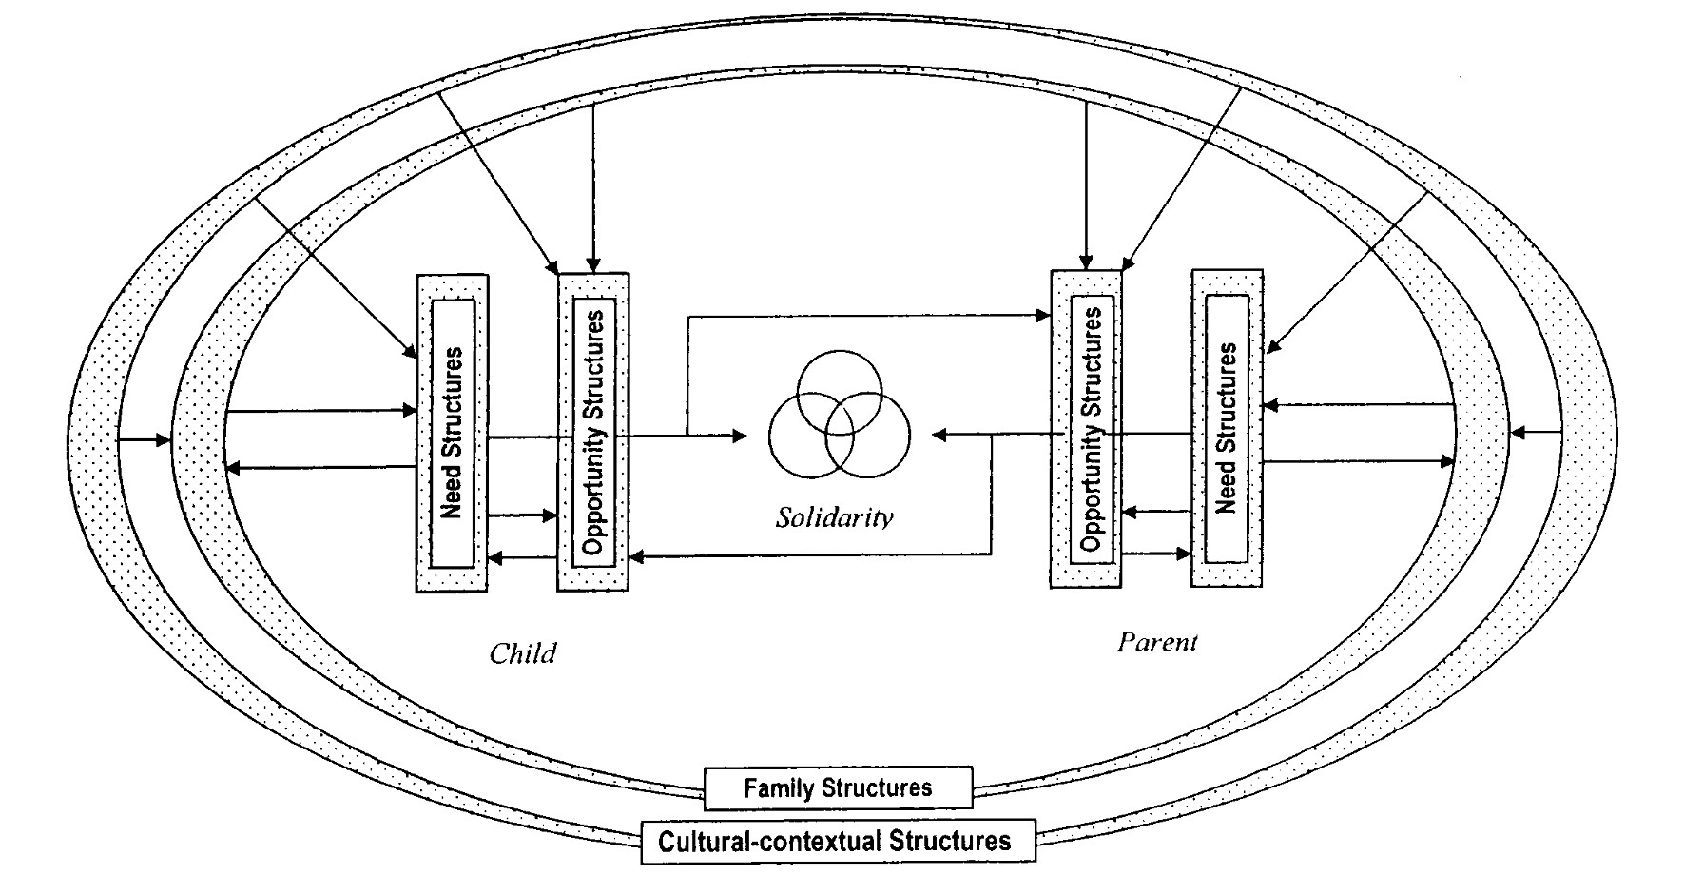

71

B Operationalization tables

B Operationalization tables

B.1 Dependent variable

|  |  |  |  |  |
| --- | --- | --- | --- | --- |
| Dimension | Used variables | Adopted scale | Description | Limitations |
| Place of resid- ence of young adults | Distance between parental household and place of resid- ence of their children (ch007_1 to ch007_8) | 0 = no cohabitation  1 = cohabitation | Following the research of Szydlik and Isen- gard (2012) as well as Courtin (2016), cohabitation includes young adults who live in the same household as well as those living in the same house. | It is not known who moved in with whom. Altough cohabitation is most likely to take place at the parental residence, there is also the possibility that parents move in to their child’s home. |

72

B Operationalization tables

B.2 Independent variables

B.2.1 Young adults

|  |  |  |  |  |
| --- | --- | --- | --- | --- |
| Dimension | Used variables | Adopted scale | Description | Limitations |
| Occupational status | Employment status of young adults (ch016_1 to ch016_8) | 0 = in education  1 = part-time  2 = full-time employed  3 = self- employed  4 = unemployed  5 = homemaker  6 = other | Homemakers in- clude young adults on parental leave as well as those looking after home and family. Re- sidual category includes young adults currently in mandatory military service as well as other minorities. | For young adults who are self-employed, it is not indicated whether they work part- or full-time. Therefore, this group has to be considered individually from all other working young adults. Deplorably, only one status at a time could be recorded. There- fore, young adults who are for example both in education and working part- time could only be categorized as one or the other. The information is provided by the young adult’s parents. This entails two problems. First, if contact frequency is low, the statement may be not up-to-date. On the same account, inaccuracies and errors are more likely as if the information was provided by the young adults themselves. Moreover, young adults may not disclose dropping out of education or losing their job for fear of defamation because feeling embarrassed. And even if they do so, parents might not feel comfort- able sharing this information with the inter- viewer. |

73

B Operationalization tables

|  |  |  |  |  |
| --- | --- | --- | --- | --- |
| Dimension | Used variables | Adopted scale | Description | Limitations |
| Level of edu- cation | ISCED- standardiz- ation of education level from 1997 (isced1997_c1 to isced1997_c8) | 1 = (pre-) primary education  2 = lower secondary education  3 = upper secondary education  4 = post-primary non-tertiary education  5 = tertiary  6 = education | To allow for interna- tional comparison, the International Stand- ard Classiﬁcation of Education (ISCED) is used. First and second stages of ter- tiary education are aggregated, as very few young adults have achieved the latter. | See above. |
| Age | Year of birth of young adult (ch006_1 to ch006_8) and year of interview of parent (int_year) | Continuous vari- able ranging from  20 to 39 years |  |  |
| Gender | Sex (ch005_1 to ch005_8) | 0 = male  1 = female |  |  |

74

B Operationalization tables

|  |  |  |  |  |
| --- | --- | --- | --- | --- |
| Dimension | Used variables | Adopted scale | Description | Limitations |
| Stage of fam- ily formation | Marital status (ch012_1 to ch012_8) and number of chil- dren (ch019_1 to ch019_8) | 0 = not married, no children  1 = not married children  2 = married, no children  3 = married, children | Following the family life cycle, four cat- egories are formed, starting with young adults living without a partner or children up to young adults who became parents and dissolved their marriage. Registered partnerships are considered equal to marriages. | See above. Unfortunately, no information on non-cohabitating, non-married partners is provided. Therefore, single young adults cannot be diﬀerentiated from those in a rela- tionship living separately. |

75

B Operationalization tables

B.2.2 Parents

|  |  |  |  |  |
| --- | --- | --- | --- | --- |
| Dimension | Used variables | Adopted scale | Description | Limitations |
| Level of edu- cation | ISCED- standardiza- tion of education level from 1997 (isced1997) | See young adults’  level of education. | See young adults’ level of education. | See above. |
| Health status | Sub jective evalu- ation of health status (sphus) | 1 = Excellent  2 = Very good  3 = Good  4 = Fair  5 = Poor | For couples, the av- erage evaluation of health is computed. With regard to single parents, their value is considered. |  |
| Financial situation in old age | Income in retirement as percentage of cur- rent income (sp109) | 1 = 0-25% of income  2 = 25-50% of income  3 = 50-75% of income  4 = 75-100% of income  5 = missing/ retired | For couples, the share of their combined income is computed. For individuals, the value is estimated using only their in- formation. Then, four categories are formed. | As parents who are retired do already re- ceive their pension, no eﬀect due to an expected change in income can be expec- ted. Thus, this indicator was only com- puted for parents who are still working. |

76

B Operationalization tables

|  |  |  |  |  |
| --- | --- | --- | --- | --- |
| Dimension | Used variables | Adopted scale | Description | Limitations |
| Age | Year of birth of par- ents (DN003_) and year of interview (int_year) | Continuous vari- able ranging from  40 to 83 years | Continuous variable ranging from 40 to 83 years If the parent is single, the mean age corresponds to the age of this respondent. |  |
| Partnership status | Marital status (DN014_) and part- ner in household (partnerinhh) | 0 = single parent  1 = couple | As children from sep- arated parents were excluded, parents with new partners are not part of the sample. Therefore, all respondents who indicate to have a partner are in rela- tionships with the other parent. |  |
| Migrational background | Country of birth (DN004) and citizen- ship (DN007_) | 0 = no migrational background  1 = migrational background | The parental home is categorized as a household with a mi- gration background if at least one parent claims to have been born in another coun- try or does not possess the nationality of the country of residence. | As only respondents who speak the national language well enough to complete the sur- vey in it were included, it can be assumed that the survey does not include the less well integrated individuals. For single parents, when the other parent was not interviewed, e.g. because he/ she already died, there is no information on this person‘s migrational background. Because of the limited inform- ation provided, it was not possible to diﬀer- entiate between households where both par- ents are migrants and those where only one parent has a migrational background as the latter can only be true for couples. |

77

B Operationalization tables

|  |  |  |  |  |
| --- | --- | --- | --- | --- |
| Dimension | Used variables | Adopted scale | Description | Limitations |
| Non- transferable Resources | Home ownership (ho002_) and value of the residence (ho024_) | 0 = no owner  1-4 = owner,  value of property  acending in  quartiles | Member of cooperat- ives are categorised as owners. | All information on housing is provided by one chosen household representative. There- fore, information may include inaccuracies depending on that person’s level of know- ledge. The aim of including the value of the house is to capture the attractiveness for the young adult to live there. However, some factors contribute to the value but not the at- tractiveness, such as the value of the land the property is built on. The accommodation’s value is only provided for home owners, no information on the value of rented property is provided. The rental price is no appropri- ate measure as it ﬂuctuates and the longer parents live in a ﬂat, the less up-to-date the information is. |
| Cohabitating household members | Relationship of all household members to coverscreen re- spondent (relrpers) | Younger siblings:  0 = no cohabitation  1 = 1 younger sibling  in household  2 = more than one  younger sibling in  household  Other young adults:  0 = no cohabitation  1 young adult in  household  2 = more than 1 young  adult in household  Grandparents:  0 = no cohabitation  1 = cohabitation | In order to model cohabitating family members, a set of three variables was created. These dif- ferentiate between cohabitating grand- parents, children under the age of  20 and other young adults living with the parents. | It is not known, how long the individual family members have been living in the re- spondent’s household or for what reason they moved in. |

78

B Operationalization tables

|  |  |  |  |  |
| --- | --- | --- | --- | --- |
| Dimension | Used variables | Adopted scale | Description | Limitations |
| Support for other family members | To whom given help (sp009_1 to sp009_3) and how often given help (sp012_1 to sp012_3) | Continuous variable from  0 = no support provided  to  5 = support provided  in high frequency  to high share of  relatives | A set of two variables was created, reﬂecting the parents’ level of support for their non- cohabitating adult children and parents. Scores were computed by aggregating the parents’ support for the respective group of relatives (excluding the child in question), then calculating the share of person who were helped, e.g. one of two adult children. This way, parents with more children do not score higher just on that account. Thereupon, the values were multiplied by the parents’ indication of support frequency with low values in- dicating a low level of support and high values the opposite. Lastly, for couples, the mean value was computed. | Unfortunately, survey respondents were only asked to name the three people who they supported the most. However, 7% of the respondents indicated to have helped more than three people. There is no in- formation in the data set on how the re- spondents gave support, e.g. housekeeping support, personal care etc. |

79

B Operationalization tables

B.2.3 Macro-level indicators

|  |  |  |  |  |
| --- | --- | --- | --- | --- |
| Dimension | Used variables | Adopted scale | Description | Limitations |
| Unemployment | Annual average of na- tional unemployment rate as percentage of active population (source: Eurostat) | Continuous vari- able ranging from  3.5% to 19.9% | The data is provided by Eurostat. Lagged indicators were used, the data being from  2010, 3 years prior to the survey interviews. |  |
| Public family support | Expenditure for fam- ily support in % of national GDP (source: SOCX) | Continuous vari- able ranging from  1.3% to 4.3% | The data is part of the OECD Social Expenditure Dataset. Lagged indicators were used (year 2010). | Information is only available for either year  2010 or 2013. Therefore, only a lag of 3 years  was possible. |
| Public old age security | Expenditure for old age security in % of national GDP (source: SOCX) | Continuous vari- able ranging from  7.6% to 12.9% | The data is part of the OECD Social Expenditure Dataset. Lagged indicators were used (year 2010). | See above. |

80

B Operationalization tables

B.2.4 Control variables

|  |  |  |  |  |
| --- | --- | --- | --- | --- |
| Dimension | Used variables | Adopted scale | Description | Limitations |
| Number of other family members in the parental household | Relationship of all household mem- bers to coverscreen respondent (relrpers) | Numeric variable | To control for space occupied by people who are not the focus of this study, it was controlled for other family members co- habitating with the parents. |  |
| Number of young adult’s siblings pre- viously not accounted for | Number of children  (CH001_) | Numeric variable | Children who were taken into account in the variables con- cerning household composition were ex- cluded here to prevent double entries |  |

References

All digital sources were last accessed on 14th July 2017 at approximately 12:00

CEST.

Aassve, A., Billari, F. C., Mazzuco, S., and Ongaro, F. (2002). Leaving home ain’t easy: A comparative longitudinal analysis of echp data. Journal of European Social Policy, 12:259–276.

Antonucci, T. (1990). Social supports and social relationships. In R. H. Binstock & L. K. George, editor, Handbook of aging and the social sciences, pages 205–226. Academic Press, New York.

Aquilino, W. S. (1990). The likelihood of parent-adult child coresidence: Eﬀects of family structure and parental characteristics. Journal of Marriage and Family,

52(2):405–419.

Avery, R., Goldscheider, F., and Jr., A. S. (1992). Feathered nest/gilded cage: Parental income and leaving home in the transition to adulthood. Demography,

29(3):375.

Baruch, J. (1999). Response rate in academic studies- a comparative analysis. Hu- man Relations, 52(4):421–438.

Baykara-Krumme, H. (2008). Immigrant families in Germany: Intergenerational solidarity in later life. Weißensee-Verlag, Berlin.

Bengtson, V. L. and Roberts, R. E. L. (1991). Intergenerational solidarity in aging families: An example of formal theory construction. Journal of Marriage and the Family, 53(4):856.

Billari, F. C. and de Valk, H. A. (2007). Living arrangements of migrant and dutch young adults: The family inﬂuence disentangled. Population studies, (61):201–

217.

Billari, F. C., Philipov, D., and Baizán, P. (2001). Leaving home in europe: The experienceof cohorts born around 1960. MPIDR Working Paper, pages 2001–2014.

Borsch-Supan, A., Brandt, M., Hunkler, C., Kneip, T., Korbmacher, J., Malter, F., Schaan, B., Stuck, S., and Zuber, S. (2013). Data resource proﬁle: the sur- vey of health, ageing and retirement in europe (share). International journal of epidemiology, 42(4):992–1001.

Bourdieu, P. (1983). The forms of capital. In J. G. Richardson, editor, Handbook of theory and research for the sociology of education, pages 241–258. Greenwood, Westport.

Brandt, M., Haberkern, K., and Szydlik, M. (2009). Intergenerational help and care in europe. European Sociological Review, 25(5):585–601.

Buck, N. and Scott, J. (1993). She’s leaving home: But why? an analysis of young people leaving the parental home. Journal of Marriage and the Family, 55(4):863.

Burn, K. and Szoeke, C. (2016). Boomerang families and failure-to-launch: Com- mentary on adult children living at home. Maturitas, 83:9–12.

Carstensen, L. L., Isaacowitz, D. M., and Charles, S. T. (1999). Taking time seri- ously: A theory of socioemotional selectivity. American Psychologist, 54(3):165–

181.

Chen, Y. and Feeley, T. H. (2014). Social support, social strain, loneliness, and well-being among older adults. Journal of Social and Personal Relationships,

31(2):141–161.

Choi, N. G. (2003). Coresidence between unmarried aging parents and their adult children: Who moved in with whom and why? Research on Aging, 25(4):384–404.

Coleman, J. S. (1988). Social capital in the creation of human capital. American

Journal of Sociology, (94):95–120.

Courtin, E. and Avendano, M. (2016). Under one roof: The eﬀect of co-residing with adult children on depression in later life. Social science & medicine (1982),

168:140–149.

Crain, W. (2010). Theories of Development: Concepts and Applications. Taylor and

Francis, London, 6th ed. edition.

Dalla Zuanna, G. (2001). The banquet of aeolus. Demographic Research, 4:133–162. de Jong Gierveld, J. and Dykstra, P. A. (2002). The long-term rewards of parenting:

Older adults’ marital history and the likelihood of receiving support from adult

children. Ageing International, 27(3):49–69.

de Jong Gierveld, J., Dykstra, P. A., and Schenk, N. (2012). Living arrangements, intergenerational support types and older adult loneliness in eastern and western europe. Demographic Research, 27:167–200.

de Jong Gierveld, J., Liefbroer, A. C., and Beekink, E. (1991). The eﬀect of parental resources on patterns of leaving home among young adults in the netherlands*. European Sociological Review, 7(1):55–71.

Deville, J. C. and Särndal, C. E. (1992). Calibration estimators in survey sampling. (87):376–382.

Dunn, T. A. and Phillips, J. W. (1998). Intergenerational co-residence and children’s incomes. Aging Studies Program Paper, (14):1–42.

Dwyer, J. W. and Coward, R. T. (1992). Gender, Families, and Elder Care. SAGE, Newbury Park.

Elder, G. H., editor (1985). Life course dynamics: Trajectories and transitions, 1968

- 1980. Cornell Univ. Pr, Ithaca, NY.

Elder, G. H. (1992). Models of the life course. Contemporary Sociology: A Journal of, (21):632–635.

Ermisch, J. (1999). Prices, parents, and young people’s household formation. Journal of Urban Economics, 45(1):47–71.

Fogli, A. (2000). Endogenous labor market rigidities and family ties. NYU Working

Paper.

Furstenberg, F. F., Kennedy, S., Mcloyd, V. C., Rumbaut, R. G., and Settersten, R. A. (2004). Growing up is harder to do. Contexts, 3(3):33–41.

Furstenberg, JR., F. F., Ruben G. Rumbaut, and Richard A. Settersen Jr. On the frontier of adulthood: Emerging themes and new directions. In Settersten (Hg.)

2008 – On the frontier of adulthood, pages 3–25.

George, L. K. (1993). Sociological perspectives on life transitions. Annual Review of Sociology, 19(1):353–373.

Giddens, A. (1986). The constitution of society: Outline of the theory of structura- tion. Univ. of California Press, Berkeley, 1. paperback ed. edition.

Giele, J. Z. and Elder, G. H., editors (1998). Methods of life course research: Qual- itative and quantitative approaches. SAGE, Thousand Oaks, Calif. and London.

Goerres, A. and Tepe, M. (2010). Age-based self-interest, intergenerational solidarity and the welfare state: A comparative analysis of older people’s attitudes towards public childcare in 12 oecd countries. European Journal of Political Research,

49(6):818–851.

Goldscheider, F. K. and DaVanzo, J. (1989). Pathways to independent living in early adulthood: Marriage, semiautonomy, and premarital residential independence. Demography, (26):545–563.

Haurin, D. R., Hendershott, P. H., and Kim, D. (1993). The impact of real rents and wages on household formation. The Review of Economics and Statistics,

75(2):284.

Huxhold, O., Fiori, K. L., and Windsor, T. D. (2013). The dynamic interplay of social network characteristics, sub jective well-being, and health: the costs and beneﬁts of socio-emotional selectivity. Psychology and aging, 28(1):3–16.

Isengard, B. and Szydlik, M. (2012). Living apart (or) together? coresidence of elderly parents and their adult children in europe. Research on Aging, 34(4):449–

474.

Kaplan, G. (2012). Moving back home: Insurance against labor market risk. Journal of Political Economy, 120(3):446–512.

Kim, S., Egerter, S., Cubbin, C., Takahashi, E. R., and Braveman, P. (2007). Poten- tial implications of missing income data in population-based surveys: An example from a postpartum survey in california. Public Health Reports, 122(6):753–763.

Klein, T., editor (2001). Partnerwahl und Heiratsmuster: Sozialstrukturelle Voraus- setzungen der Liebe. Springer Fachmedien Wiesbaden GmbH, Wiesbaden.

Kohli, M. (1985). Die institutionalisierung des lebenslaufs. historische befunde und theoretische argumente. Kölner Zeitschrift für Soziologie und Sozialpsychologie, (37):1–29.

Le Blanc, D. and Laferrère, A. (2004). Gone with the windfall: How do housing allowances aﬀect student co-residence? CESifo Economic Studies, 50(3):451–477.

Le Blanc, D. and Wolﬀ, F.-C. (2006). Leaving home in europe: The role of par- ents’and children’s incomes. Review of Economics of the Household, (4):53–73.

Lee, G. and Dwyer, J. W. (1996). Aging parent-adult child coresidence. Journal of

Family Issues, 17(1):46–59.

Levinson, D. J. (1986). A conception of adult development. American Psychologist,

41(1):3–13.

Liefbroer, A. C. and Billari, F. C. (2010). Bringing norms back in: A theoret- ical and empirical discussion of their importance for understanding demographic behaviour. Population, Space and Place, 16(4):287–305.

Macmillan, R. and Copher, R. (2005). Families in the life course: Interdependency of roles, role conﬁgurations, and pathways. Journal of Marriage and Family,

67(4):858–879.

Ma jorano, M., Musetti, A., Brondino, M., and Corsano, P. (2015). Loneliness, emo- tional autonomy and motivation for solitary behavior during adolescence. Journal of Child and Family Studies, 24(11):3436–3447.

Manacorda, M. and Moretti, E. (2006). Why do most italian youths live with their parents? intergenerational transfers and household structure. Journal of the European Economic Association, 4(4):800–829.

Mayer, K. U. (2009). New directions in life course research. Annual Review of

Sociology, 35(1):413–433.

McFadden, D. L. (1979). Quantitative methods for analyzing travel behaviour of individuals: Some recent developments. In Hensher, D. A. and Stopher, P. R., editors, Behavioural travel modelling, pages 279–318. Croom Helm, London.

McLanahan, S. (2004). Diverging destinies: How children are faring under the second demographic transition. Demography, 41(4):607–627.

Mitchell, B. A. (1998). Too close for comfort? parental assessments of "boomerang kid" living arrangements. Canadian Journal of Sociology / Cahiers canadiens de sociologie, 23(1):21.

Mitchell, B. A. (2004). Home, but not alone: Socio-cultural and economic aspects of canadian young adults sharing parental households. 28(4):115–125.

Mitchell, B. A., Wister, A., and Gee, E. M. T. (2004). The ethnic and family nexus of homeleaving and returning among canadian young adults. The Canadian Journal of Sociology, 29(4):543–575.

Mitchell, B. A., Wister, A. V., and Gee, E. M. (2000). Culture and co-residence: An exploration of variation in home-returning among canadian young adults*. Canadian Review of Sociology/Revue canadienne de sociologie, 37(2):197–222.

Munich Centre for the Economics of Aging (2017). Data documentation- sample. Neugarten, B. L. and Hagestad, G. O. (1976). Age and the life course. In R. H.

Binstock and E. Shanas, editors, Handbook of aging and the social sciences, pages

35–55. Van Nostrand Reinhold, New York.

Ogg, J. and Renaut, S. (2006). The support of parents in old age by those born during 1945–1954: A european perspective. Ageing and Society, 26(05):723–743.

Organisation for Economic Co-operation and Development (2012). OECD Social

Expenditure Statistics. OECD Publishing.

Parrott, T. M. and Bengtson, V. L. (1999). The eﬀects of earlier intergenerational aﬀection, normative expectations, and family conﬂict on contemporary exchanges of help and support. Research on Aging, 21(1):73–105.

Payne, K. and Copp, J. (2013). Young adults in the parental home and the great recession.

Riley, M. W. and Riley, J. W. (1993). Connections: Kin and cohort. In V. L.

Bengtson & W. A. Achenbaum, editor, The changing contract across generations,

pages 169–190. Springer, New York.

Sandberg-Thoma, S. E., Snyder, A. R., and Jang, B. J. (2015). Exiting and returning to the parental home for boomerang kids. Journal of Marriage and the Family,

77(3):806–818.

Schmertmann, C. P., Boyd, M., Serow, W., and White, D. (2000). Elder-child coresidence in the united states: Evidence from the 1990 census. Research on Aging, 22(1):23–42.

Settersten, R. A. (1998). A time to leave home and a time never to return? age constraints on the living arrangements of young adults. Social Forces, 76(4):1373–

1400.

Settersten, R. A. and Hagestad, G. O. (1996). What’s the latest? cultural age deadlines for family transitions. The Gerontologist, 36(2):178–188.

Sewell, W. H. (1992). A theory of structure: Duality, agency, and transformation.

American Journal of Sociology, 98(1):1–29.

Silverstein, M. and Bengtson, V. L. (1997). Intergenerational solidarity and the structure of adult child–parent relationships in american families. American Journal of Sociology, 103(2):429–460.

Silverstein, M., Conroy, S. J., Wang, H., Giarrusso, R., and Bengtson, V. L. (2002).

Reciprocity in parent-child relations over the adult life course. The journals of

gerontology. Series B, Psychological sciences and social sciences, 57(1):S3–13.

Silverstein, M., Gans, D., and Yang, F. M. (2006). Intergenerational support to aging parents. Journal of Family Issues, 27(8):1068–1084.

Solon, G., Haider, S., and Wooldridge, J. (2013). What Are We Weighting For?

National Bureau of Economic Research, Cambridge, MA.

Sorenson, S. and Zarit, S. H. (1996). Preparation for caregiving: A study of mul- tigenerational families. International Journal of Aging and Human Development,

2:43–46.

South, S. J. and Lei, L. (2015). Failures-to-launch and boomerang kids: Contem- porary determinants of leaving and returning to the parental home. Social Forces,

94(2):863–890.

Stapleton, C. M. (1980). Reformulation of the family life-cycle concept: implications for residential mobility. Environment & planning A, 12(10):1,103–18.

Stone, J., Berrington, A., and Falkingham, J. (2014). Gender, turning points, and boomerangs: Returning home in young adulthood in great britain. Demography,

51(1):257–276.

Szydlik, M. (2000). Lebenslange Solidarität? Generationenbeziehungen zwischen erwachsenen Kindern und Eltern, volume 2 of Lebenslauf - Alter - Generation. Leske + Budrich, Opladen.

Szydlik, M. (2008). Intergenerational solidarity and conﬂict. Journal of Comparative

Family Studies, (39):97–114.

Thornton, A., Fricke, T., Yang, L., and & Chang, J. (1994). Theoretical mechanisms of family change. In Thornton, A. and Lin, H., editors, Social Change and the Family in Taiwan, pages 88–115. University of Chicago Press, Chicago.

Ward, R., Logan, J., and Spitze, G. (1992). The inﬂuence of parent and child needs on coresidence in middle and later life. Journal of Marriage and the Family,

54(1):209.

Weiss, R. (2005). Retirement, marriage, and social isolation. Illness, Crisis and

Loss, (13):75–84.

White, L. (1994). Coresidence and leaving home: Young adults and their parents.

Annual Review of Sociology, (20):81–102.

Whittington, L. A. and Peters, H. E. (1996). Economic incentives for ﬁnancial and residential independence. Demography, 33(1):82.

**Eidesstattliche Erklärung**

von

Hiermit versichere ich, dass ich die Masterarbeit – bei einer Gruppenarbeit meinen gekennzeichneten Teil der Arbeit – selbständig und lediglich unter Benutzung der angegebenen Quellen und Hilfsmittel verfasst habe.

Ich versichere außerdem, dass die vorliegende Arbeit noch nicht einem anderen

Prüfungsverfahren zugrunde gelegen hat.

Ich bin damit einverstanden / nicht damit einverstanden, dass ein Exemplar meiner

Masterarbeit in der Bibliothek ausgeliehen werden kann.

Berlin, den

(Unterschrift)

2